Instalar sql server driver Ubuntu

1. sudo apt get ./libcurl3_7.58.0-2ubuntu2_amd64.deb
2. sudo su
3. curl https://packages.microsoft.com/keys/microsoft.asc | apt-key add -
4. curl https://packages.microsoft.com/config/ubuntu/$(lsb_release -rs)/prod.list > /etc/apt/sources.list.d/mssql-release.list
5. exit
6. sudo apt-get update
7. sudo ACCEPT_EULA=Y
8. sudo apt-get install ./msodbcsql_13.1.9.2-1_amd64.deb
9. sudo apt get ./libssl1.0.0_1.0.2n-1ubuntu5_amd64.deb
10. sudo apt get ./libjemalloc1_3.6.0-2.focal_amd64.deb
11. sudo apt get ./msodbcsql_13.1.9.2-1_amd64.deb – solo si no se instaló el paso 8
12. O CON: sudo dpkg -i ./<package>
13. ===================INTENTAR CON =========================
14. sudo apt-get sudo pecl install sqlsrv
15. sudo pecl install pdo_sqlsrv install -y unixodbc-dev
16. sudo nano /etc/php/7.4/cli/conf.d/30-pdo_sqlsrv.ini (add: extension=pdo_sqlsrv.so)
17. sudo nano /etc/php/7.4/cli/conf.d/20-sqlsrv.ini (add: extensión=sqlsrv.so)
18. ====================ALTERNATIVA=================
19. Instalar PEAR
20. wget https://pear.php.net/go-pear.phar
21. sudo mkdir /opt/pear7.4/
22. sudo chown guillen:guillen /opt/pear7.4/
23. mv go-pear.phar /opt/pear7.4/
24. cd /opt/pear7.4/
25. ls (go-pear.phar)
26. php go-pear.phar
27. ls -l /tmp/ | grep -i pear
28. sudo chown guillen:guillen /tmp/pear -R
29. php go-pear.phar
    1. press: 1, then enter: /opt/pear7.4/
    2. next….
30. cd bin - (pear peardev pecl)
31. sudo ./pecl install pdo_sqlsrv

Remover package: sudo apt renove <package>

sudo ./pecl uninstall sqlsrv

Install SQL SERVER WINDOWS

<https://www.microsoft.com/es-mx/download/details.aspx?id=30438>

Descargar e instalar

SQLEXPR_x64_ENU.exe  
SQLManagementStudio_x64_ENU.exe

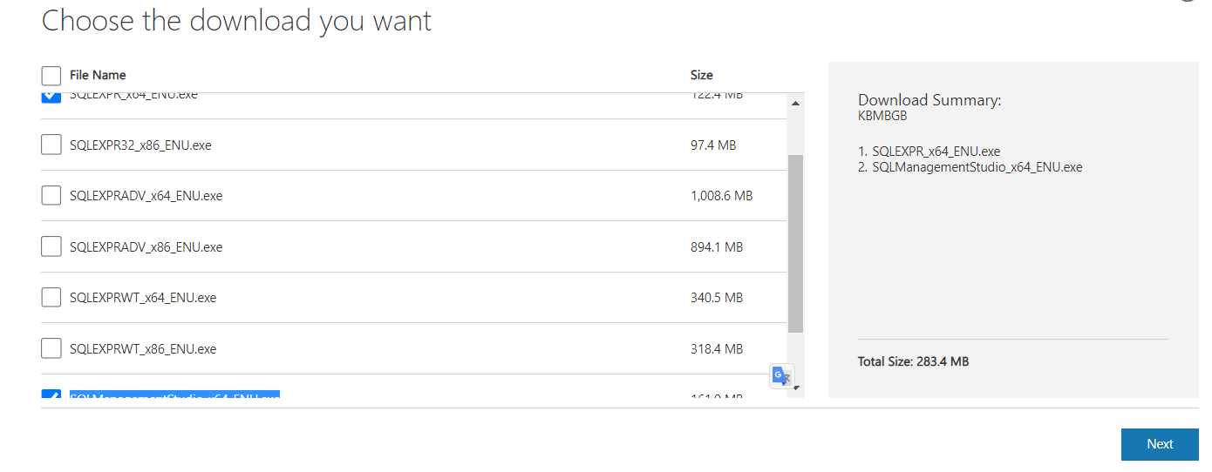

Abrir:

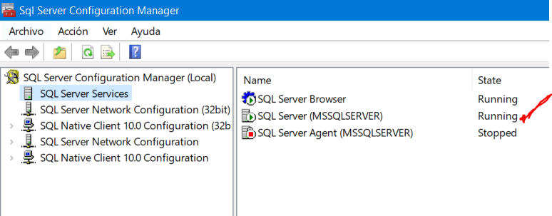

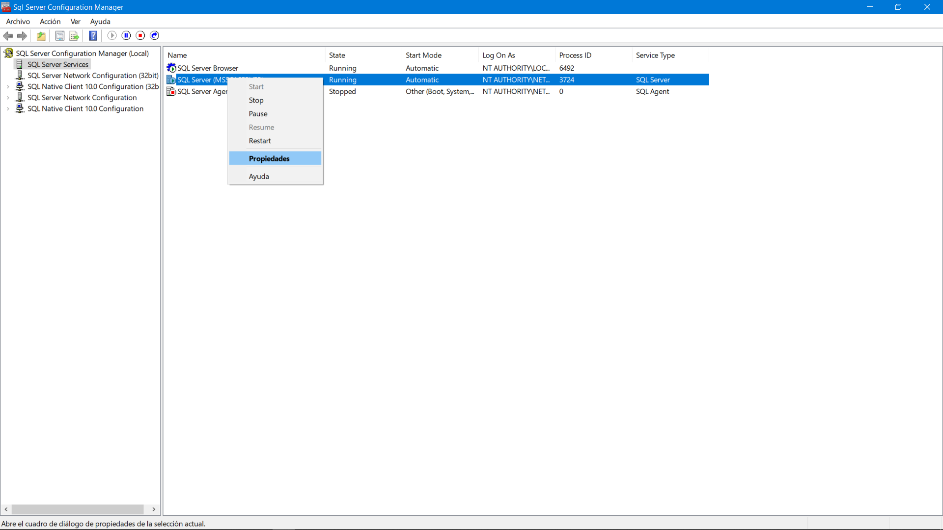

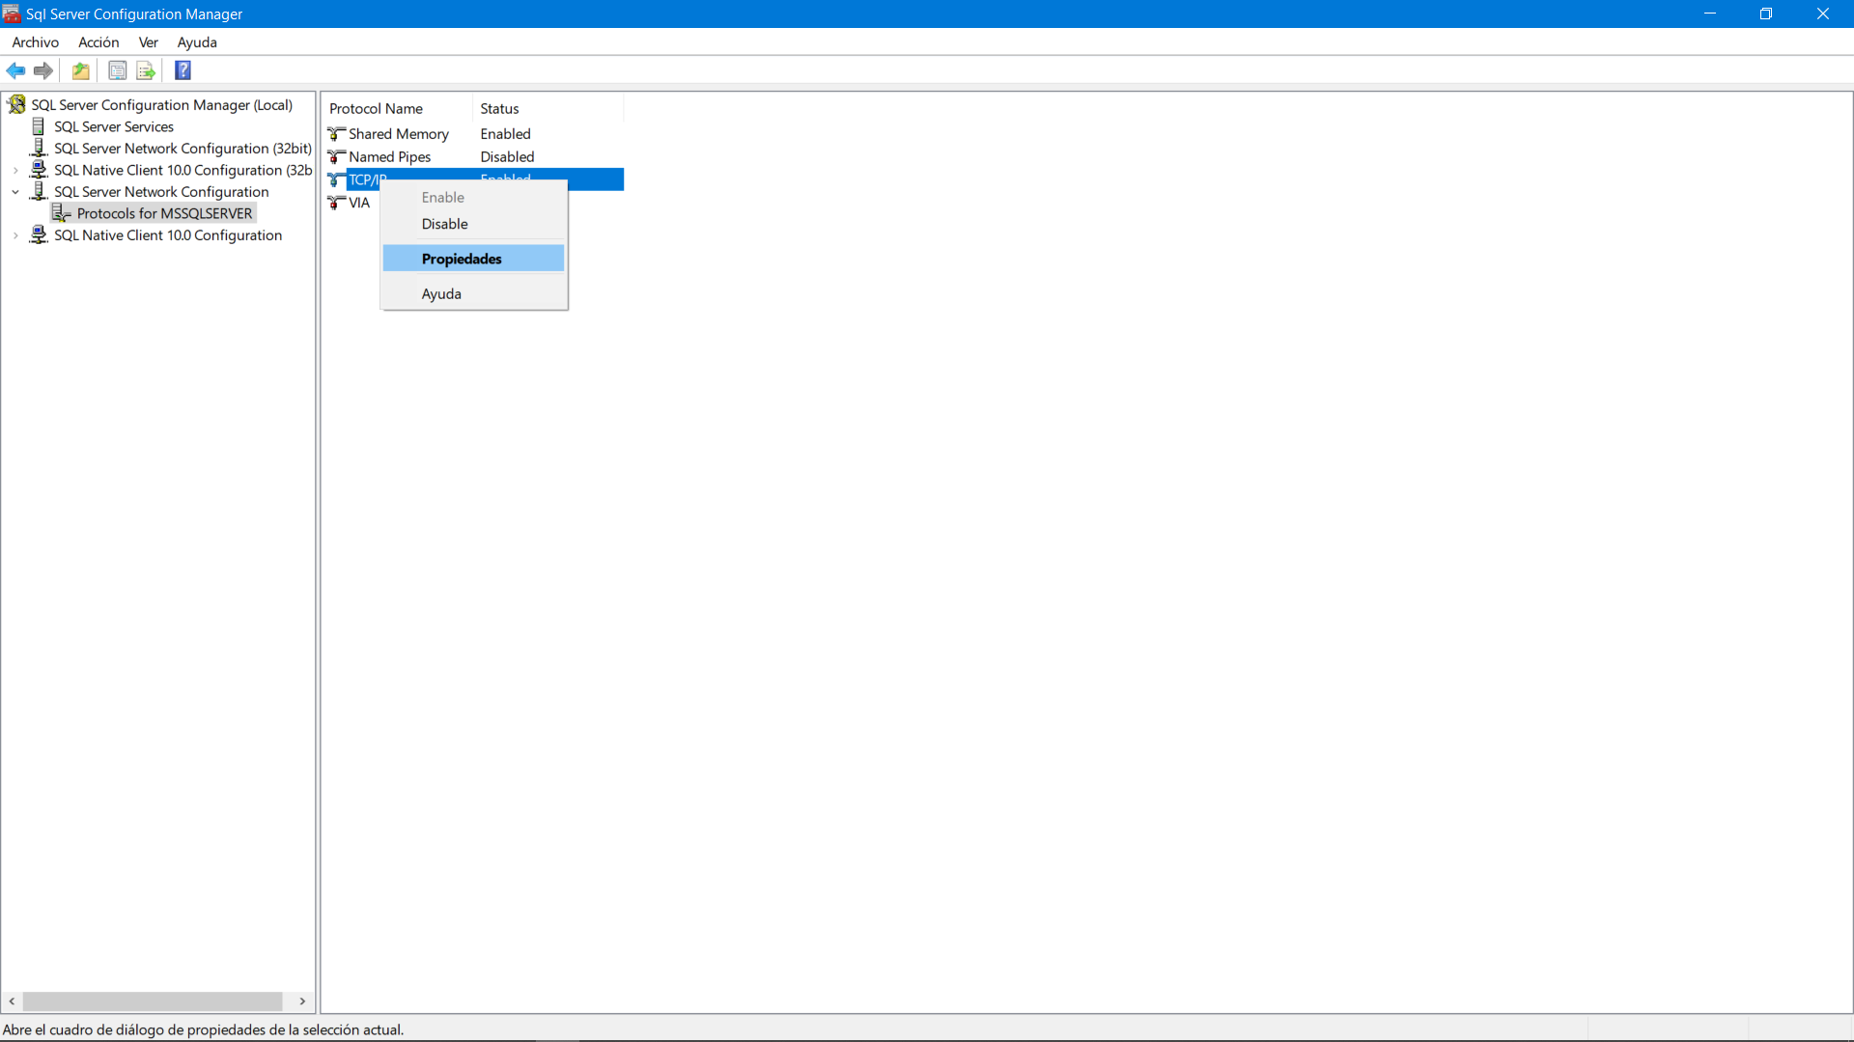

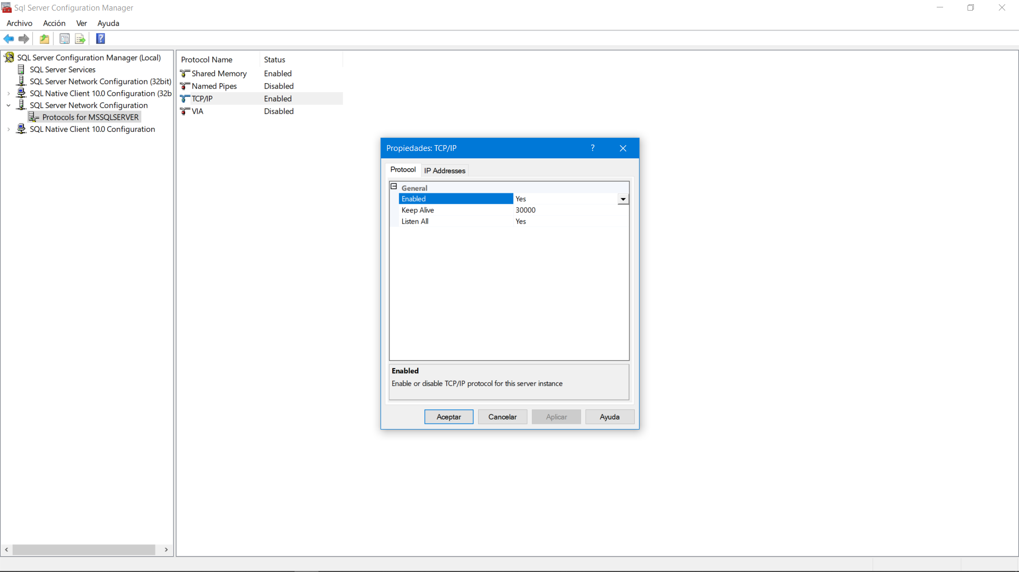

Host de conexion: No funciona localhost

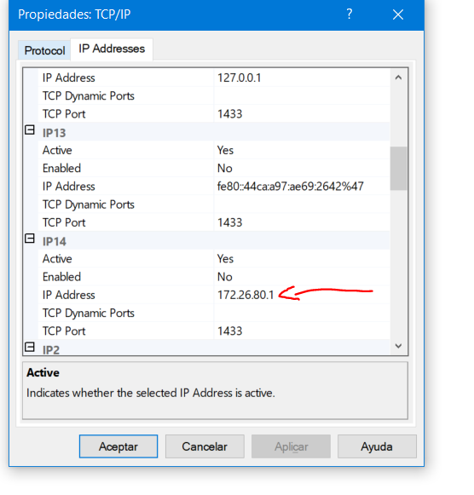

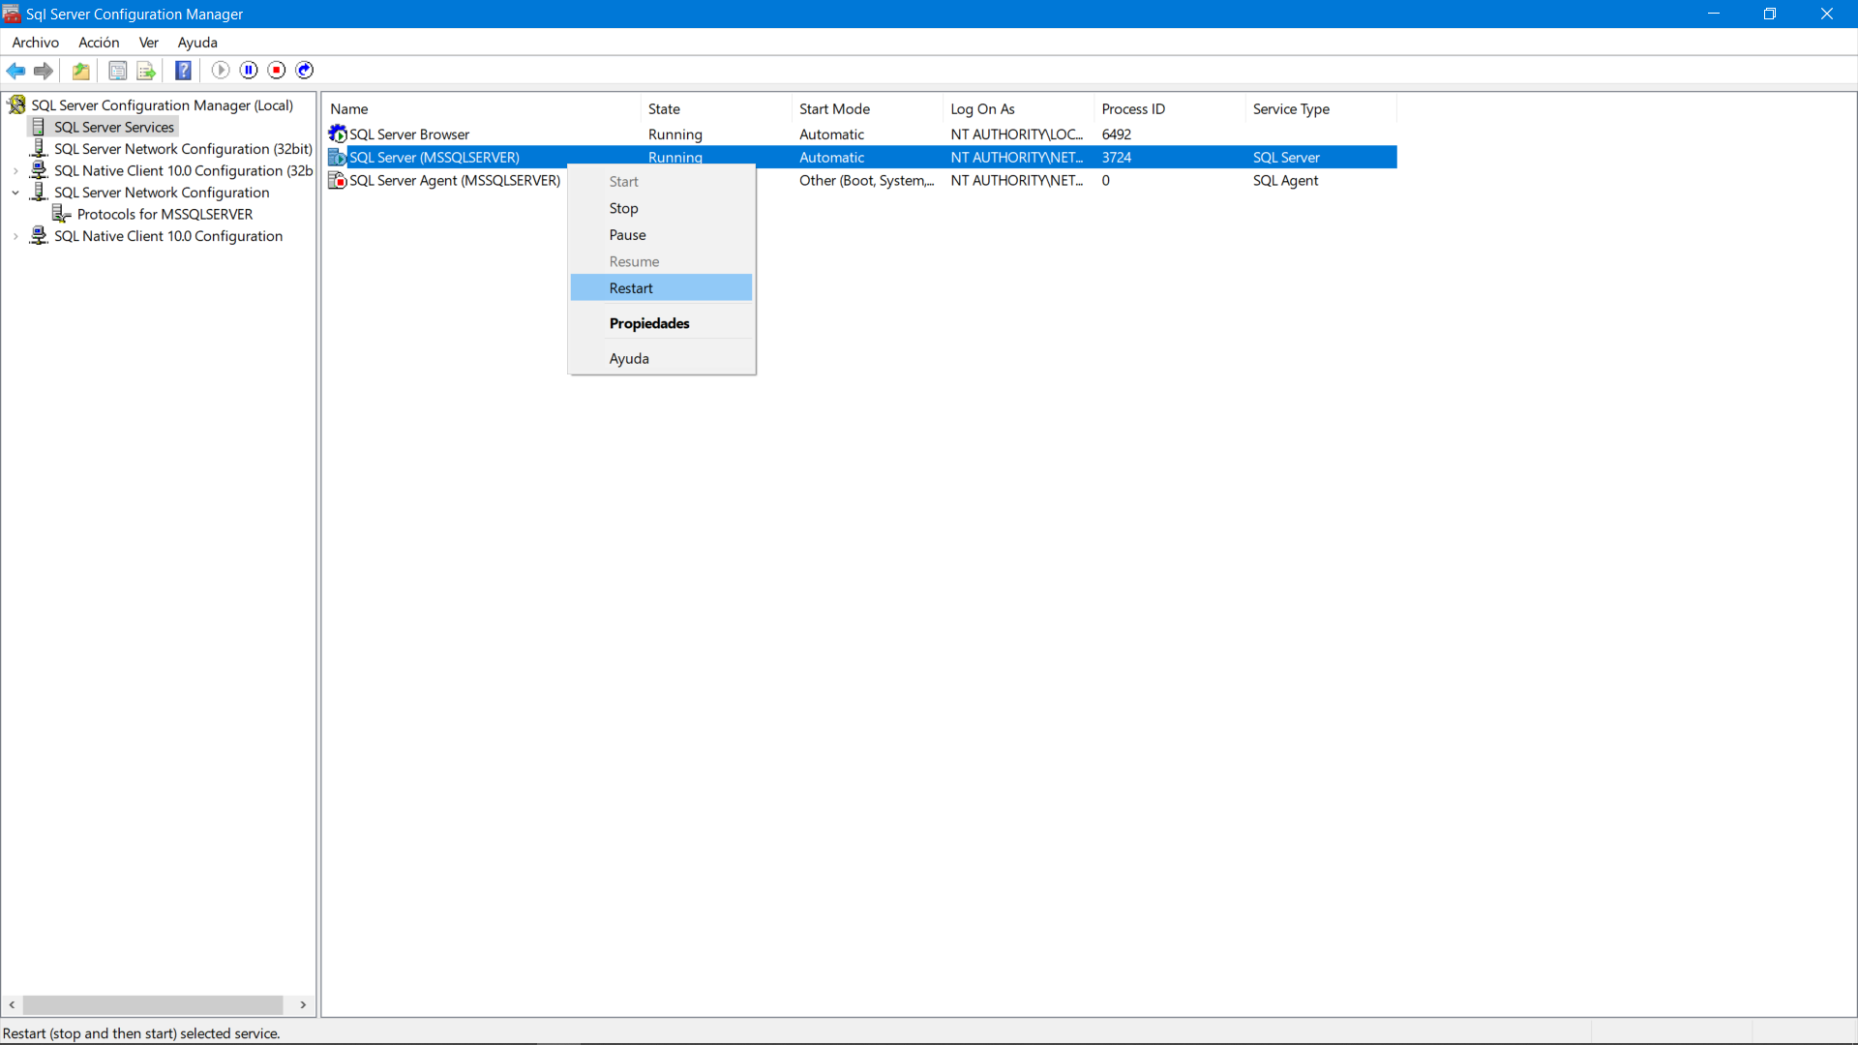

MANAGEMENT STUDIO: CREAR NUEVO USER

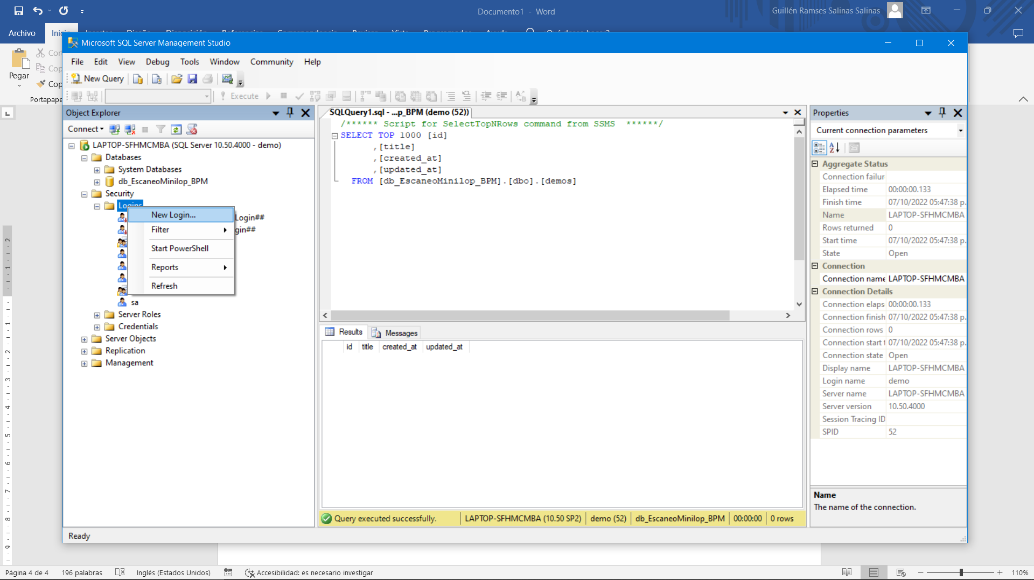

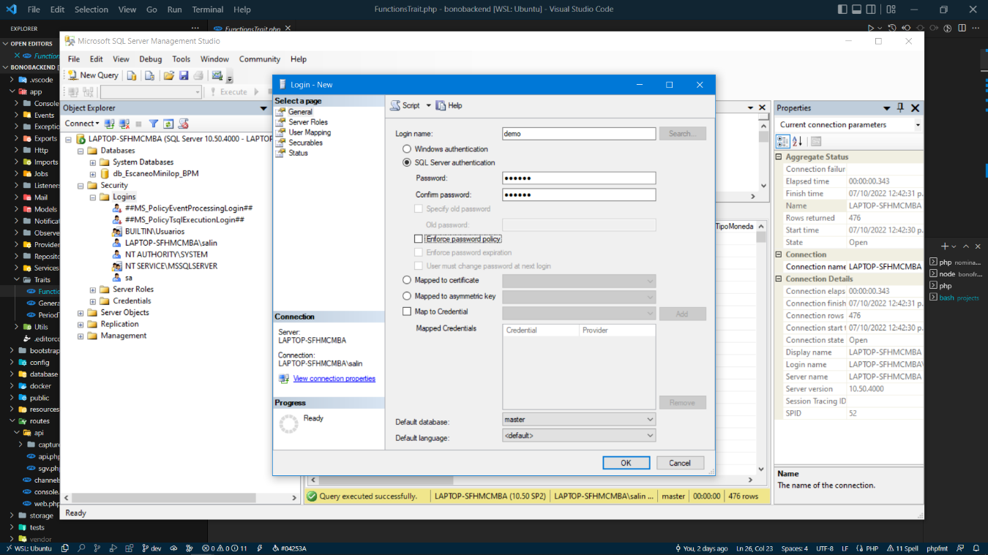

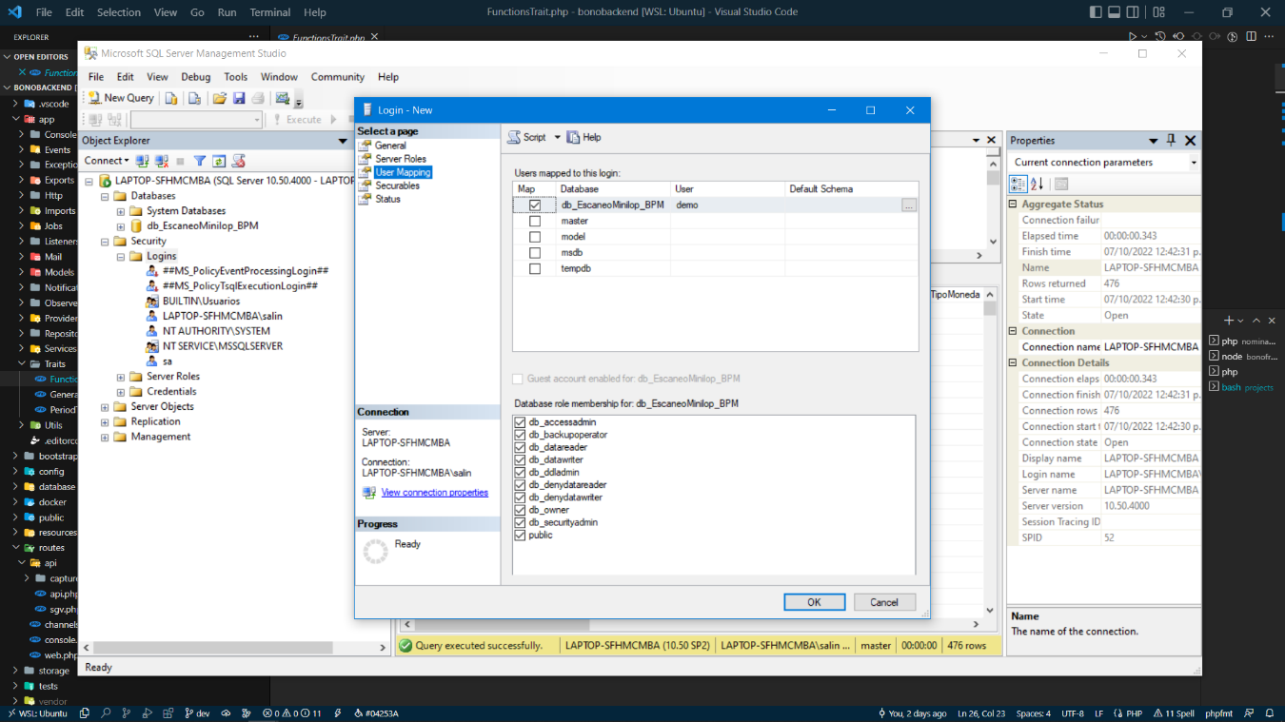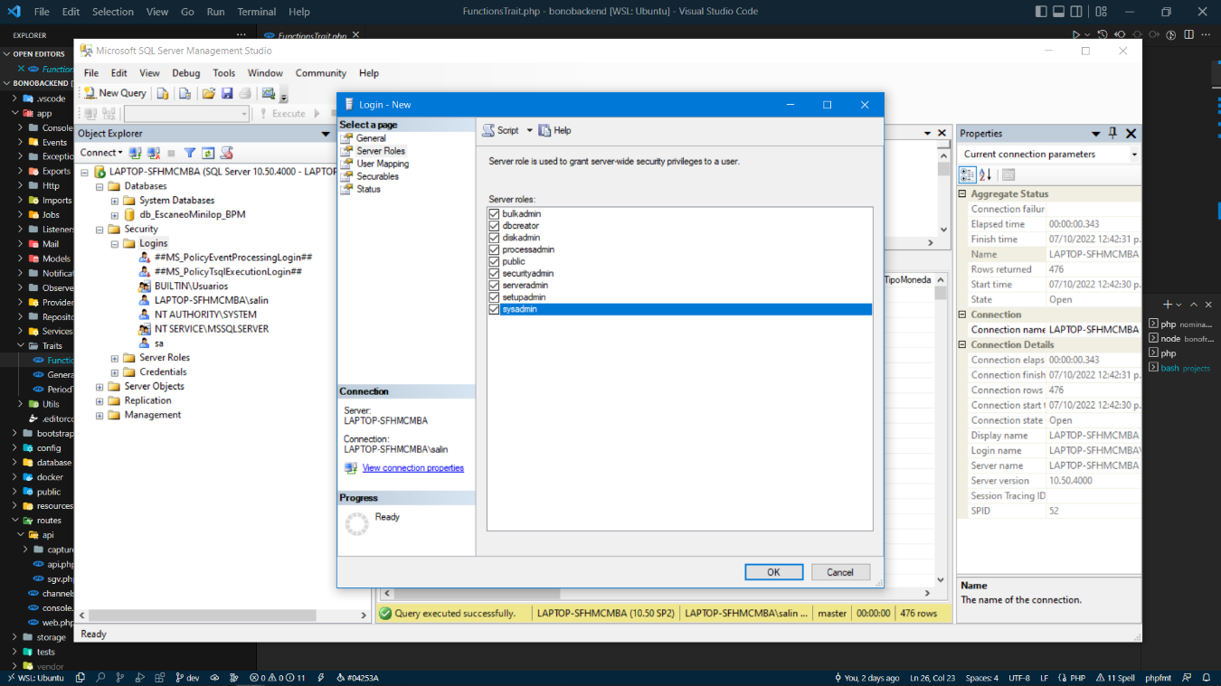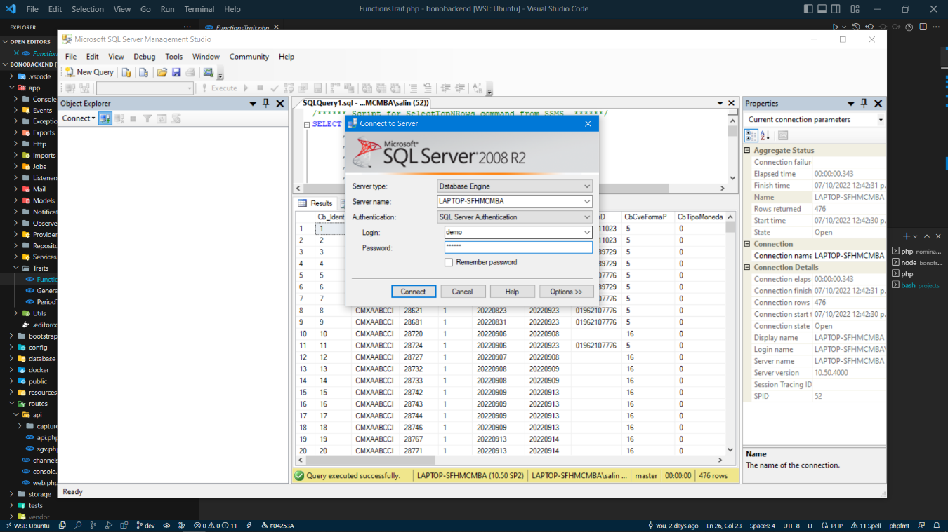Configurar FIREWAL DE WINDOWS

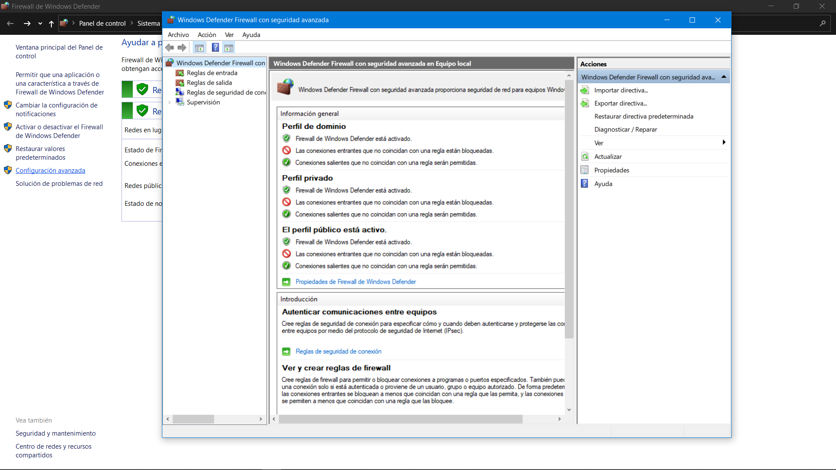

Reglas de entrada

Nueva entrada

Puerto

Next

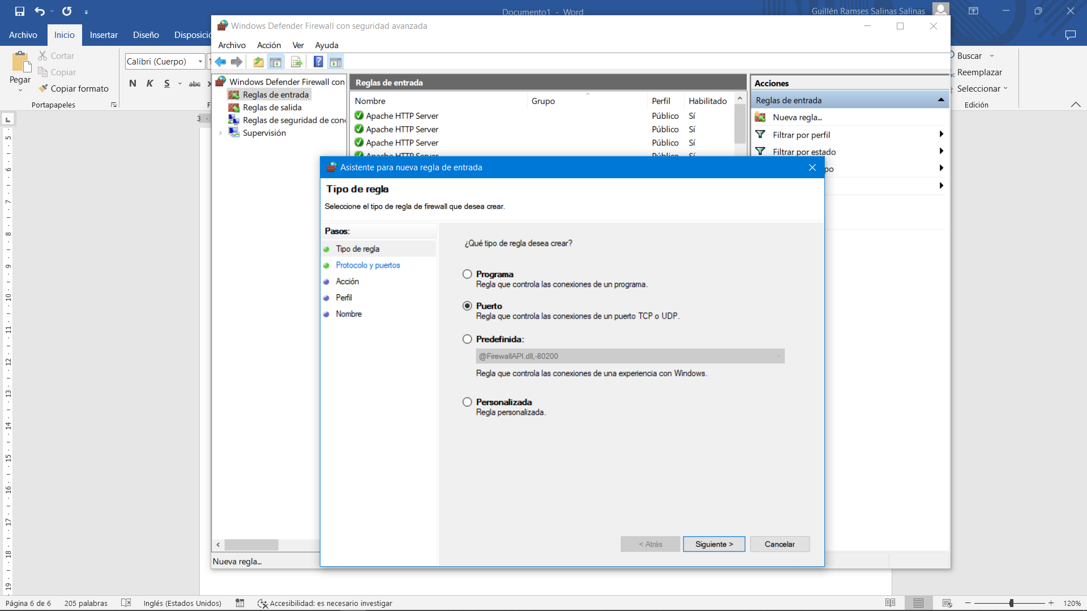

Agregar puerto

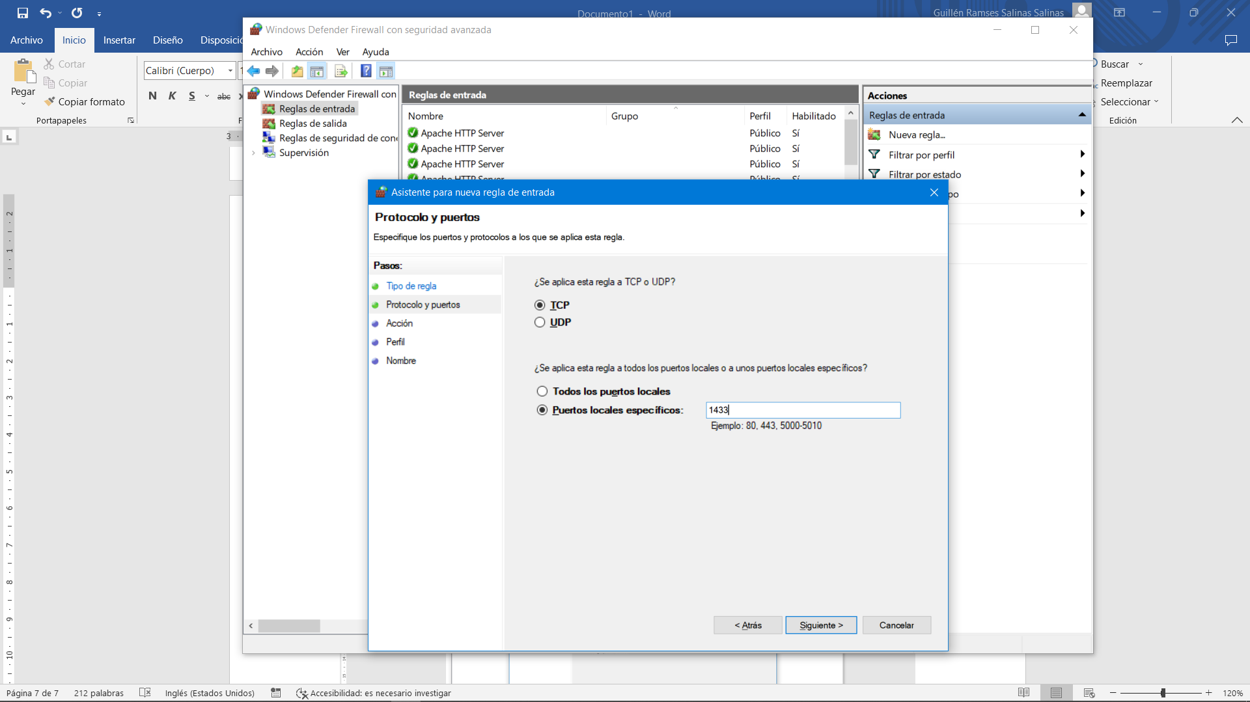

Next, next, next, agregar nombre no importa mucho. Realizar el mismo proceso para Reglas de salida.

Provar conexión

Crear un archivo de .php

<?php

$serverName = "tcp:172.26.80.1,1433"; //serverName\instanceName

// Since UID and PWD are not specified in the $connectionInfo array,

// The connection will be attempted using Windows Authentication.

$connectionInfo = ["Database"=>"db_EscaneoMinilop_BPM", "UID" => "demo", "PWD"=>"qwerty"];

$conn = sqlsrv_connect( $serverName, $connectionInfo);

if( $conn ) {

echo "Connection established.<br />";

}else{

echo "Connection could not be established.<br />";

die( print_r( sqlsrv_errors(), true));

}

?>

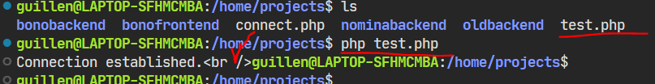

LARAVEL

Config/database.php

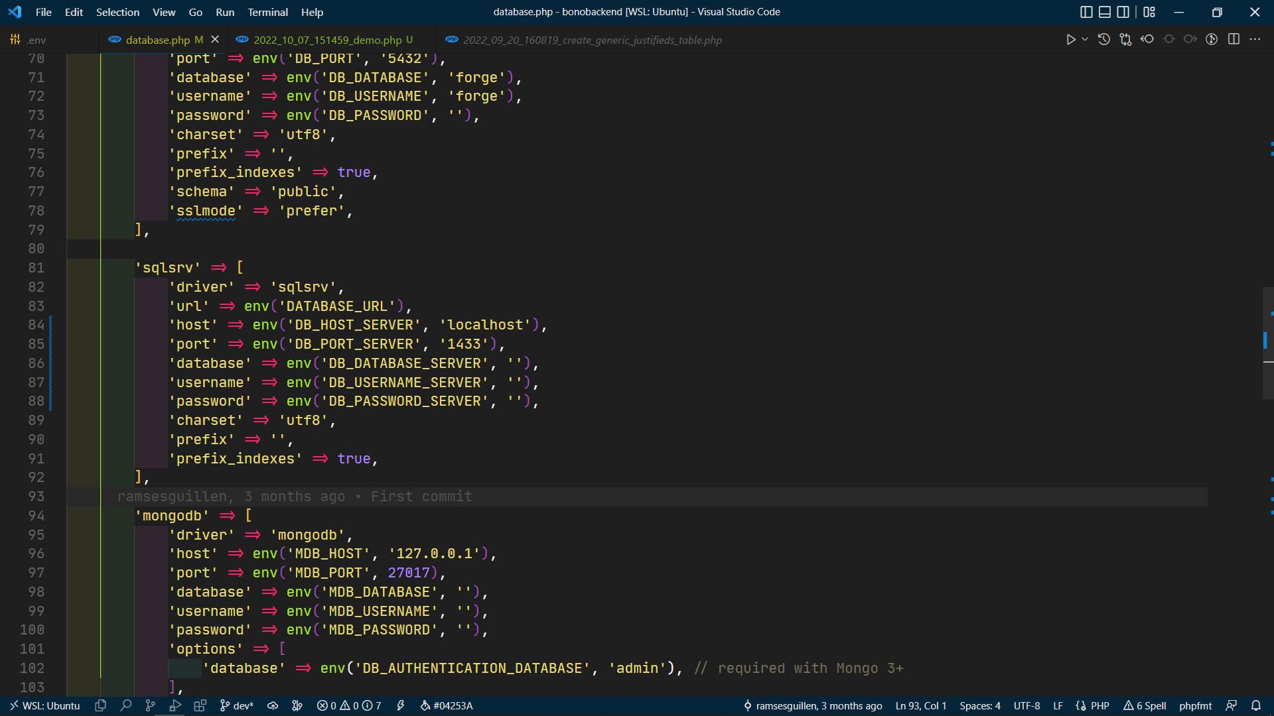

.env

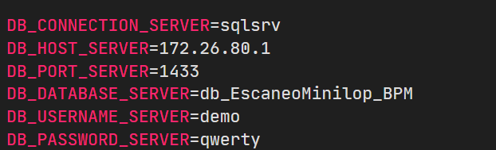

Crear migración

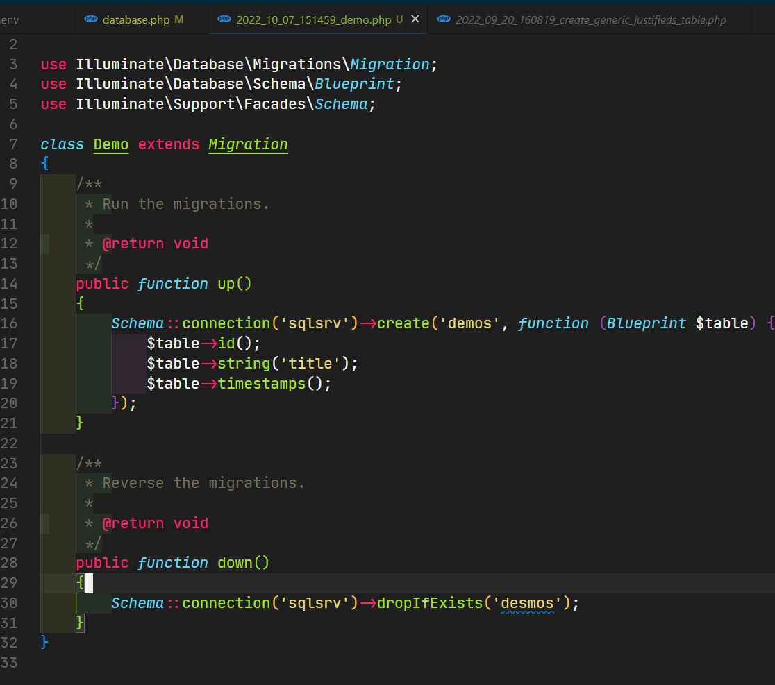

Php artisan migrate

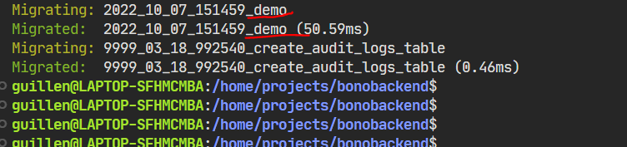

DONE!!!!